Design Documentation

***Contents***

Visual/Interface designs ........................................................................................................ 2

Logo .................................................................................................................................. 2

Colour Scheme.................................................................................................................. 2

With # ............................................................................................................................ 2

Array.............................................................................................................................. 2

Object ............................................................................................................................ 2

Navigation bar ................................................................................................................... 3

Home Page ....................................................................................................................... 5

About Page ....................................................................................................................... 6

Educational Visits Page..................................................................................................... 7

Booking System ................................................................................................................ 8

Log In/ Register................................................................................................................. 9

Data requirements .............................................................................................................. 12

ERD.............................................................................................................. 12

Data types ................................................................................................................ 13

Data dictionary ................................................................................................................ 13

Site Map............................................................................................................................. 15

User Flow Diagram............................................................................................................................. 15

Flowcharts (signup)............................................................ 15

Flowcharts (login)................................................ 16

Flowcharts (logout).......................... 16

Flowcharts (Saving Billing Information (from checkout))............................... 17

Flowcharts (Grab Billing Information (from checkout))................................................ 16

Flowcharts (Booking Zoo Tickets)................................................ 16

Flowcharts (Display Zoo Availability)................................................ 16

Flowcharts (Booking Hotel Rooms)................................................ 16

Flowcharts (Display Hotel Availability)................................................ 16

A test strategy..................................................................................................................... 20

**Visual/Interface designs**

**Logo**



**Colour Scheme**



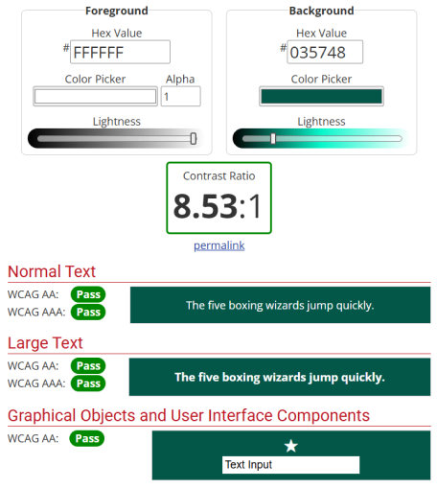

**Navigation bar**



**Home Page**

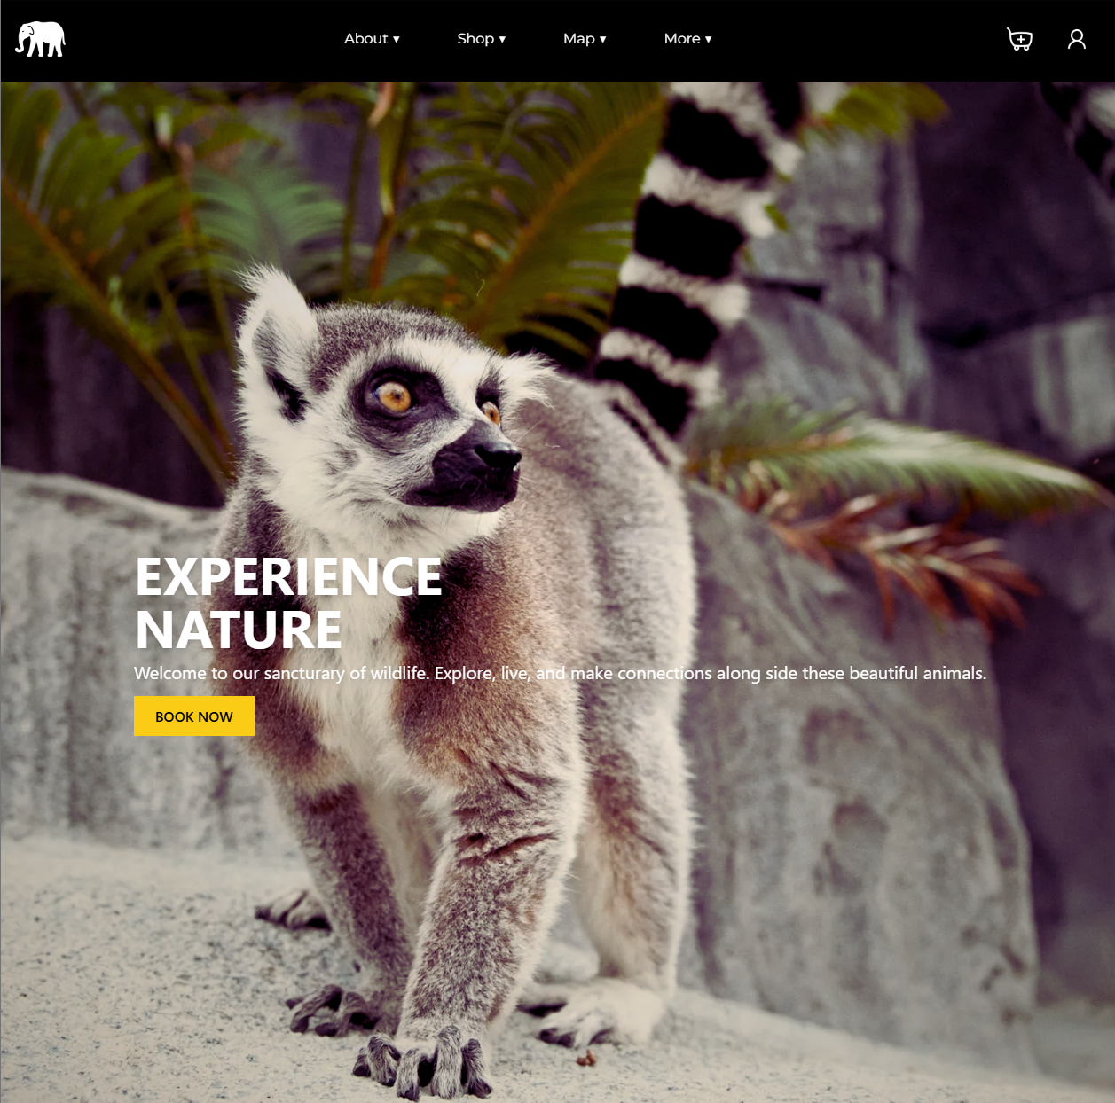

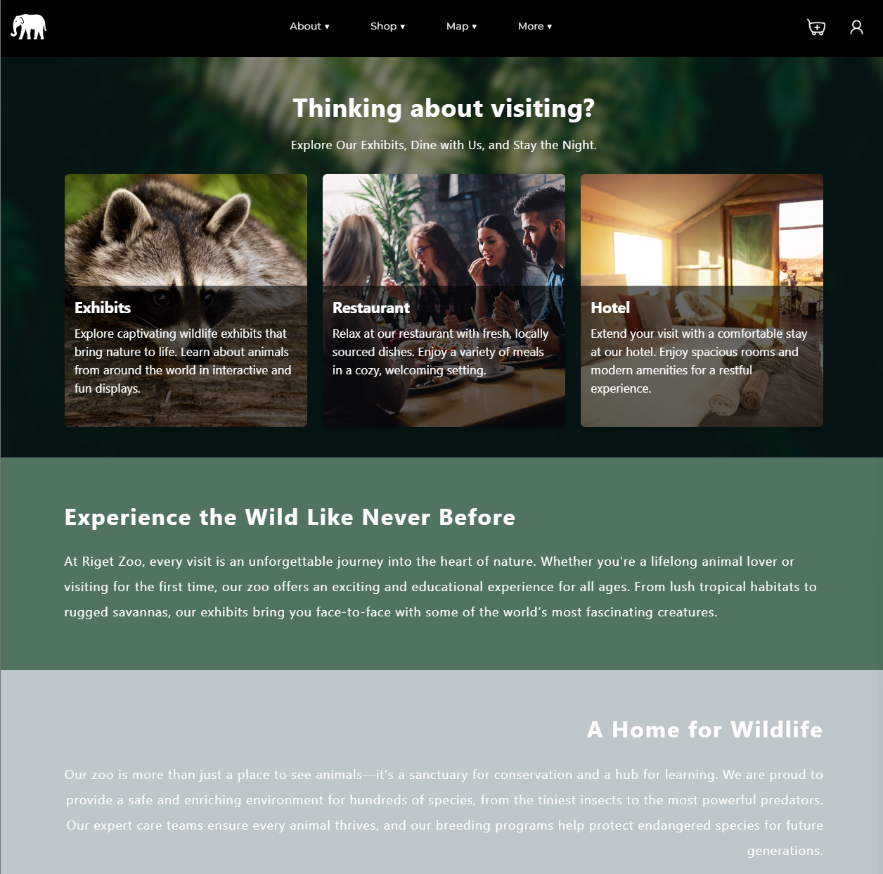

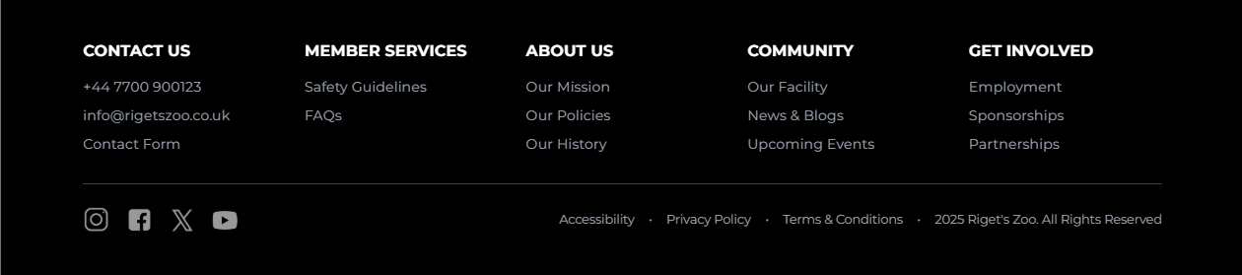

**About Page**

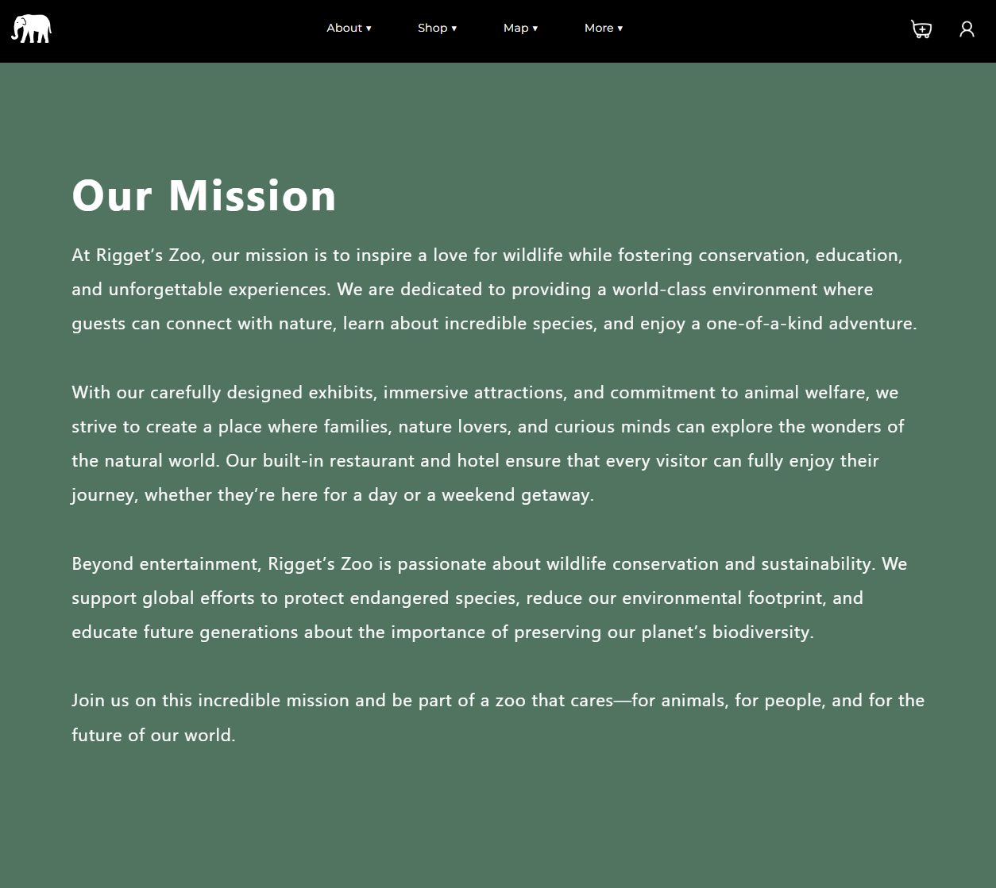

**Educational Visits Page**

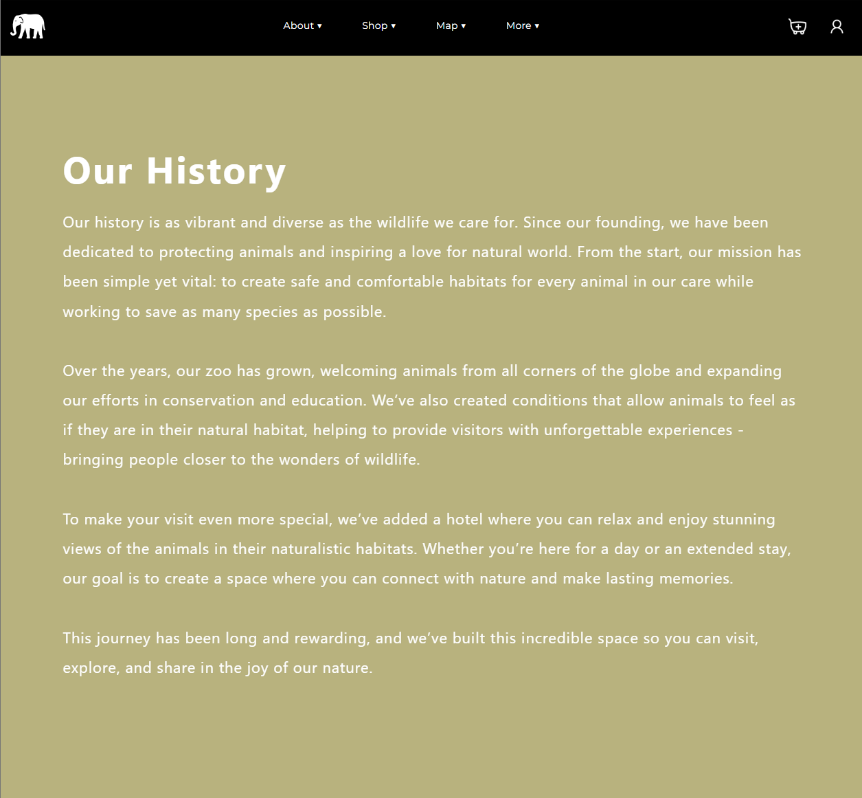

**Booking System**

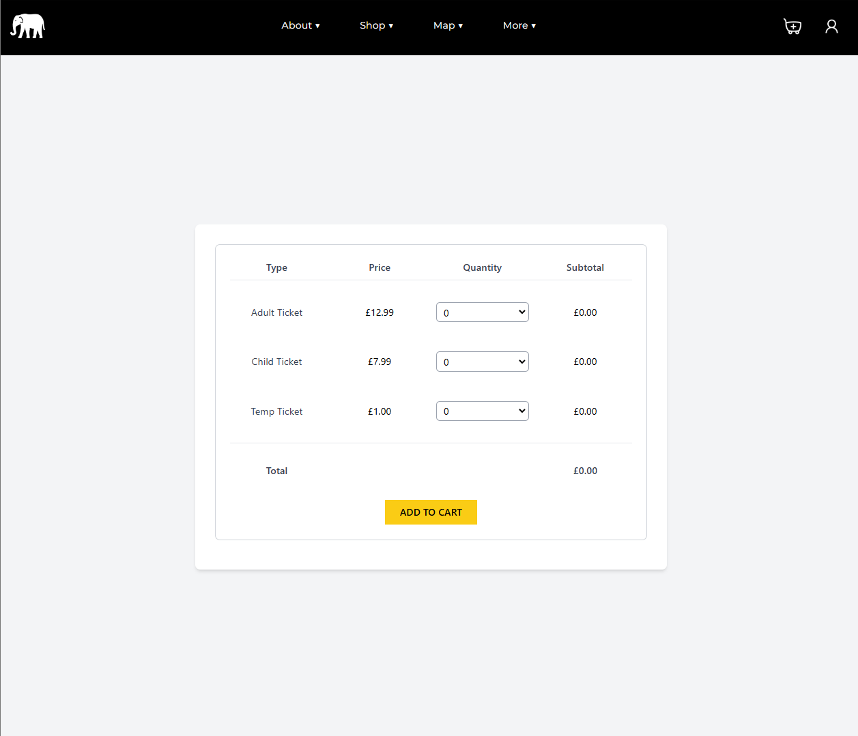

**Log In/ Register**

Login

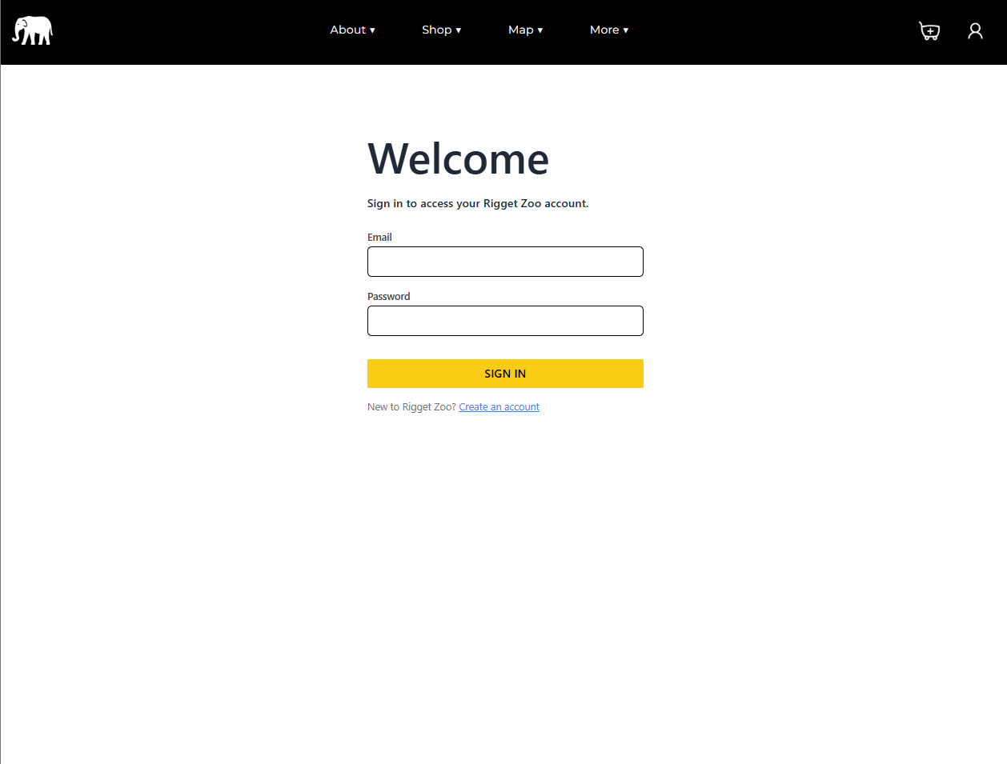

Register

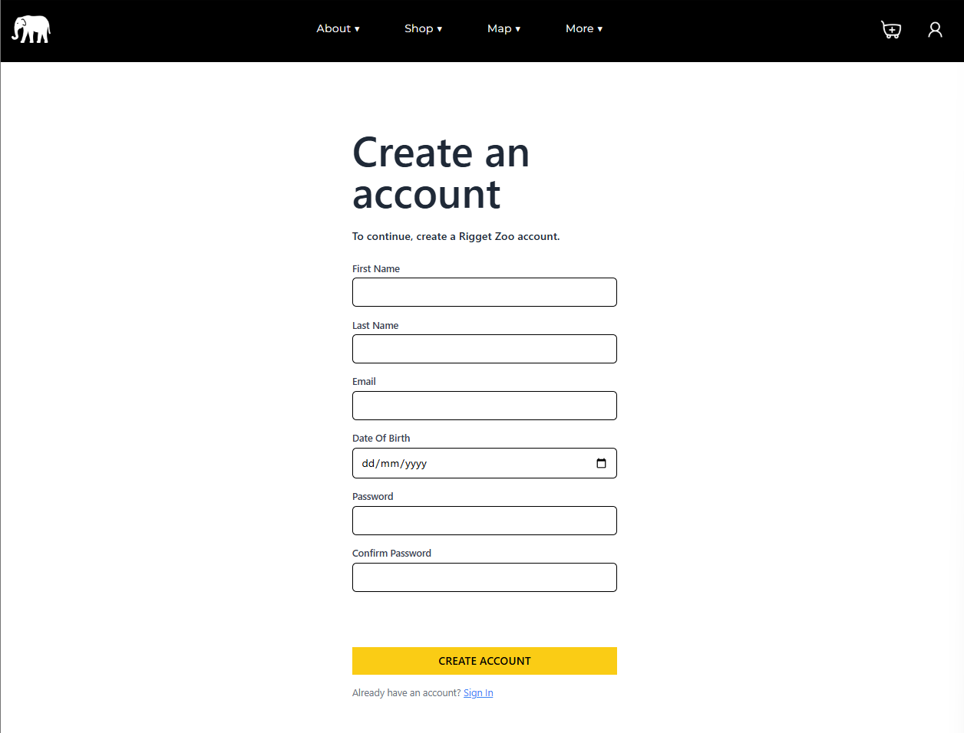

Account details

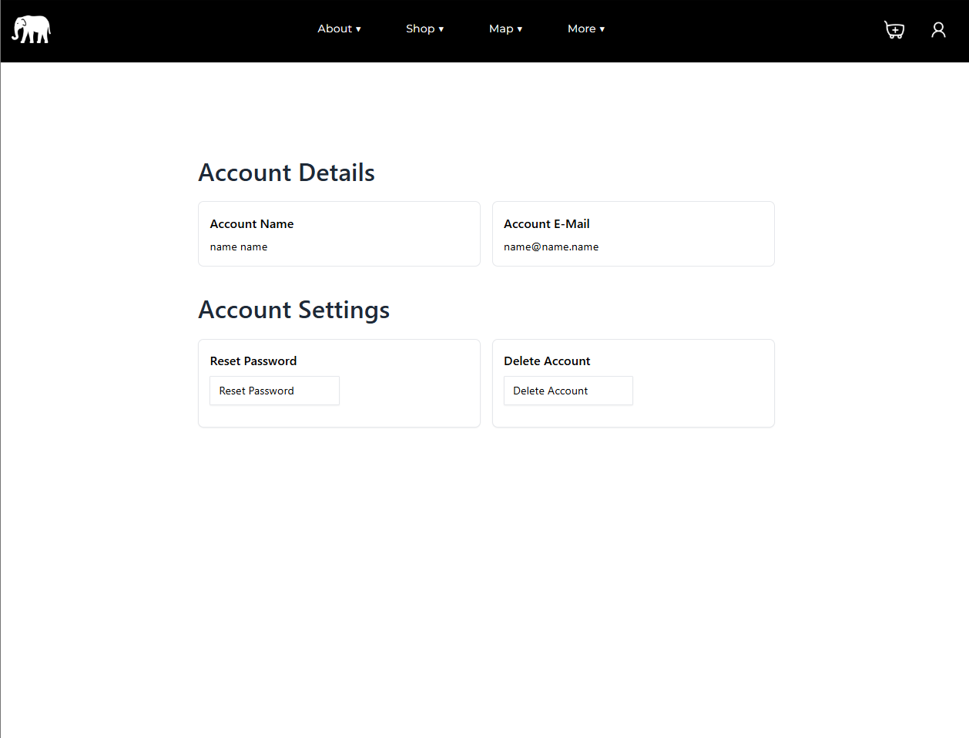

**Data requirements**

ERD

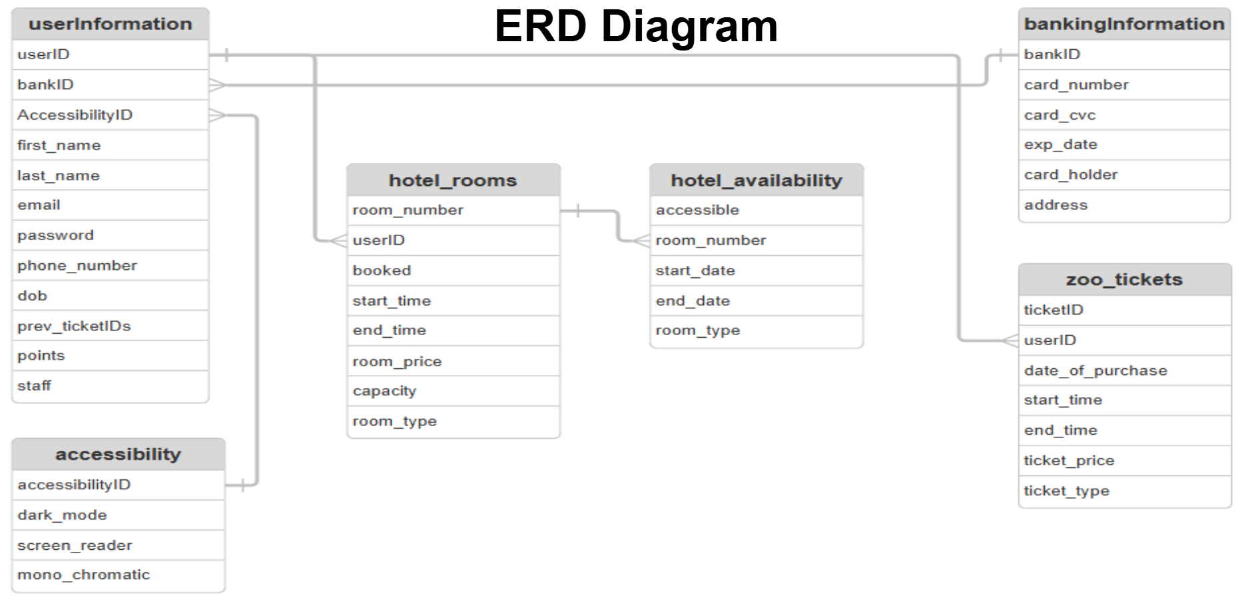

**Data types**

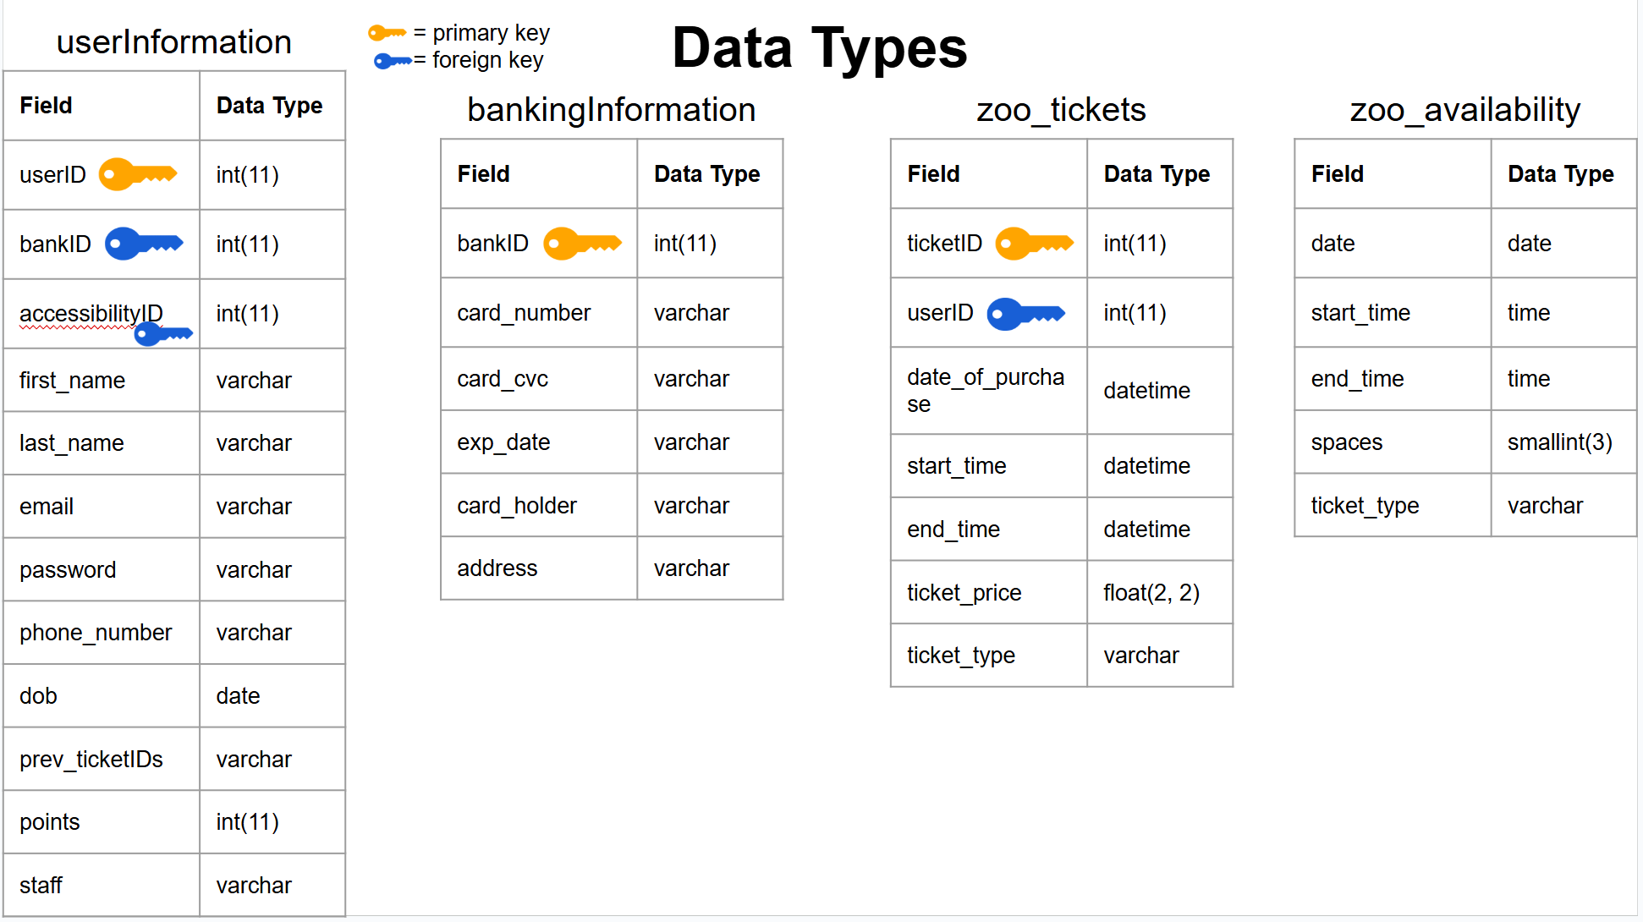

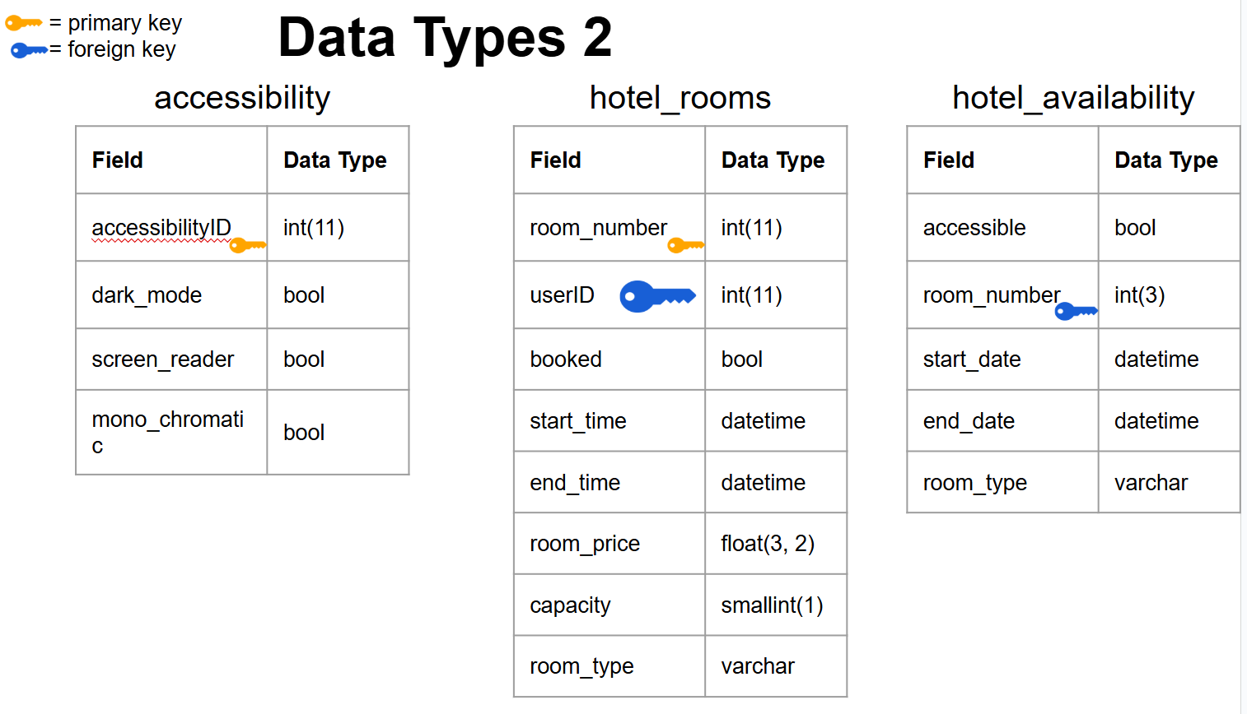

**Data dictionary**

userInformation

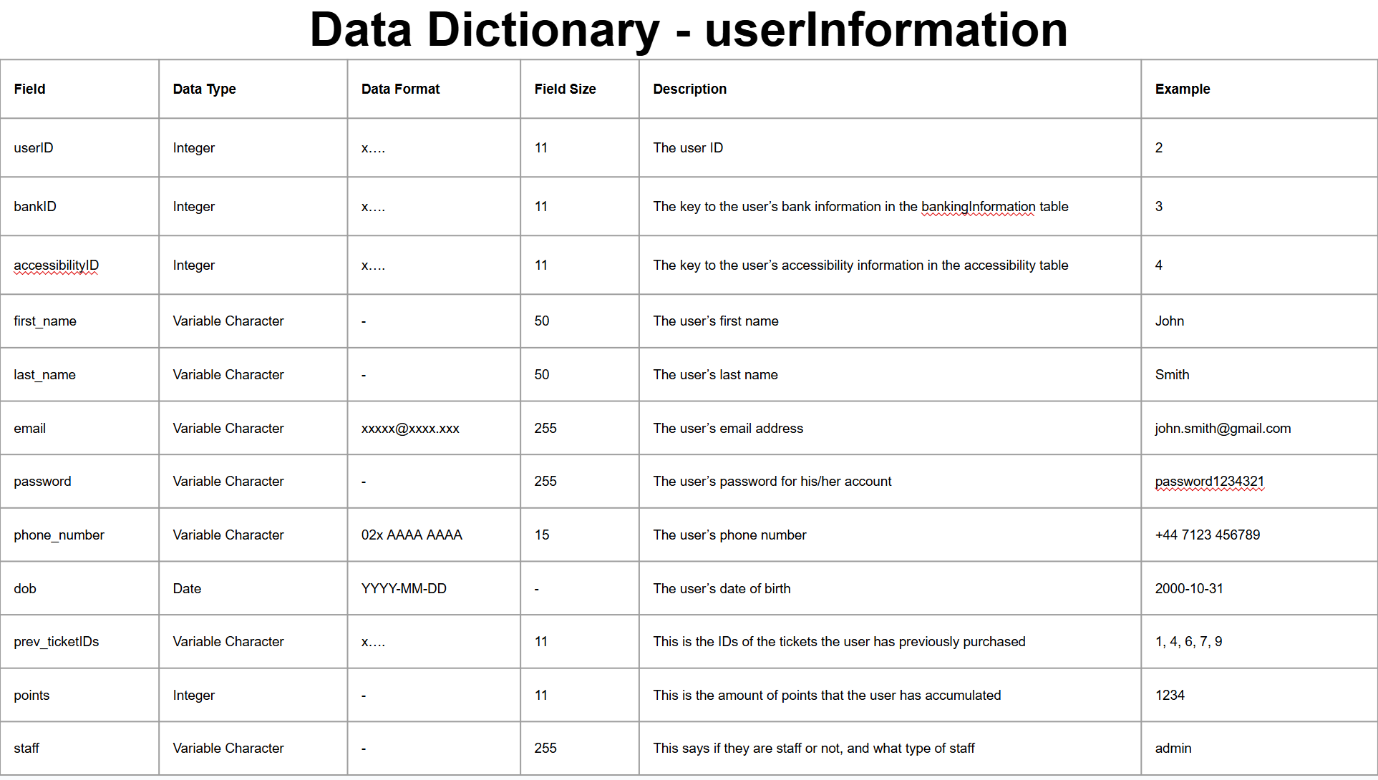

bankingInformation

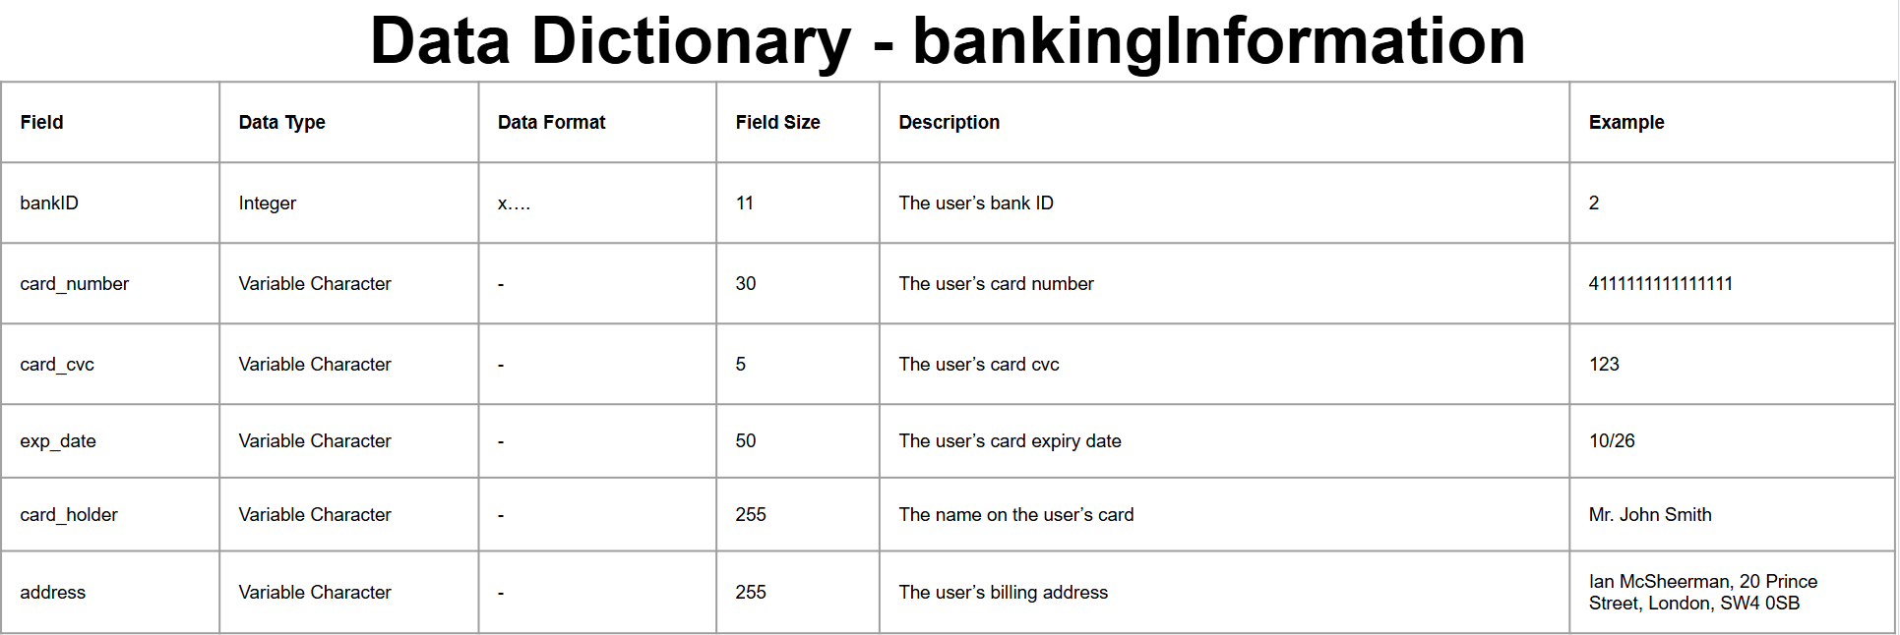

zoo_tickets

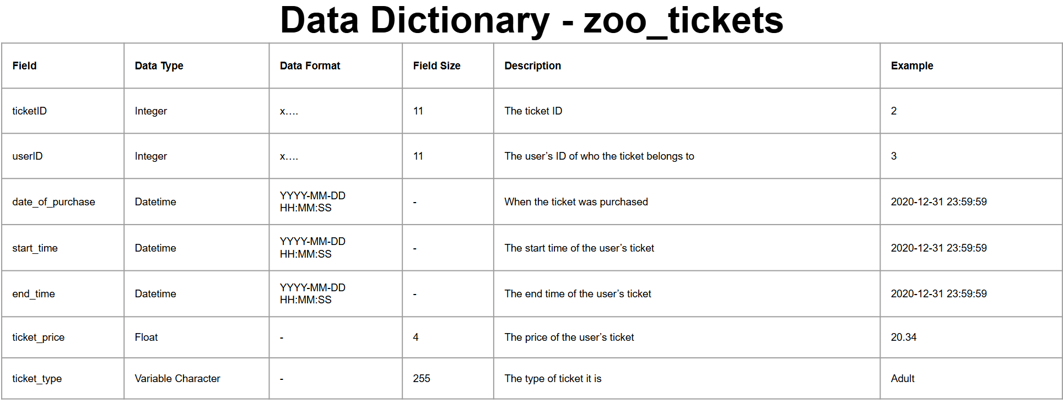

zoo_availability

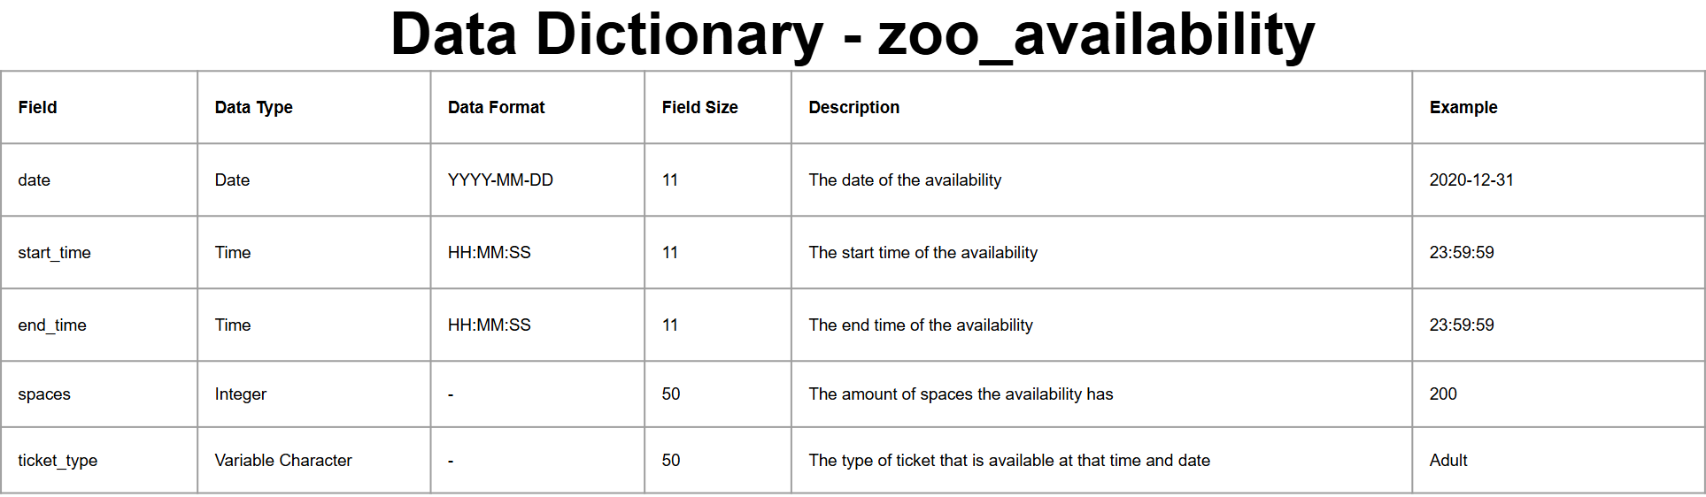

hotel_rooms

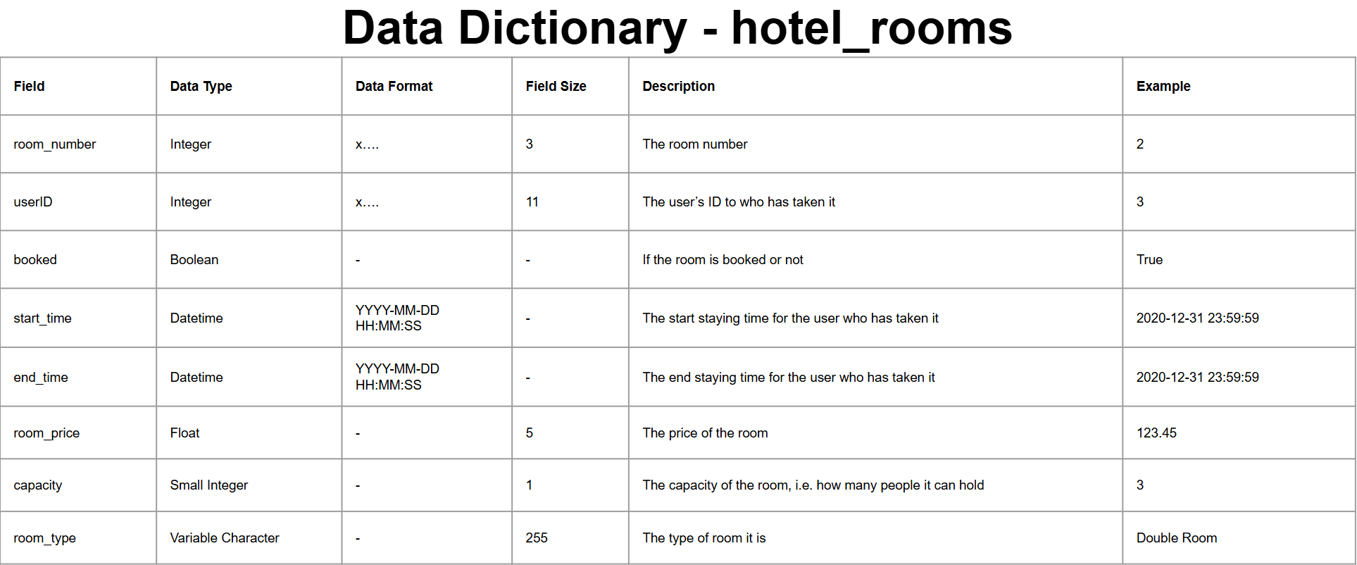

hotel_availability

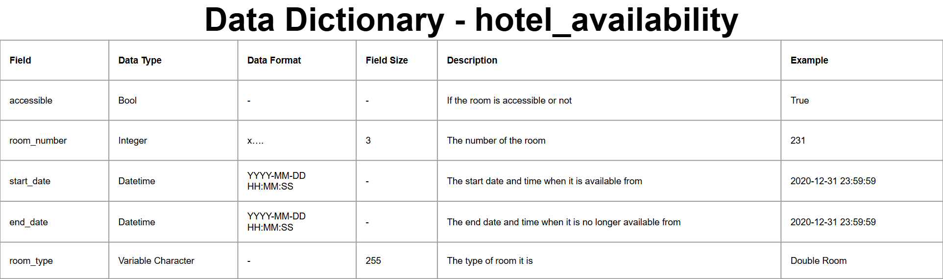

**Site Map**

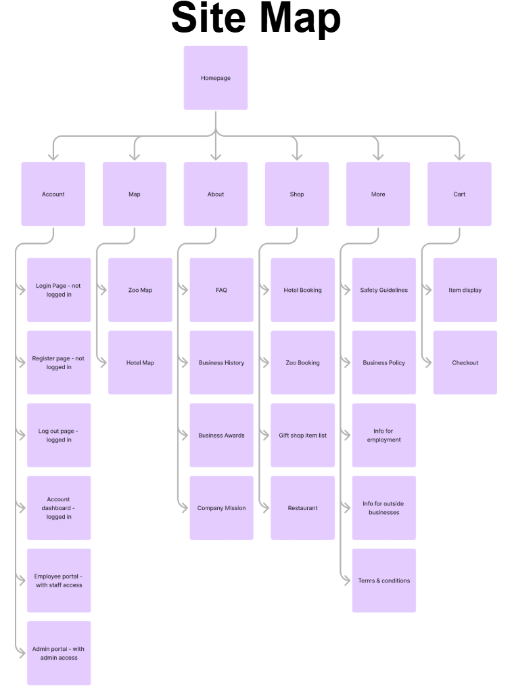

**User Flow Diagram**

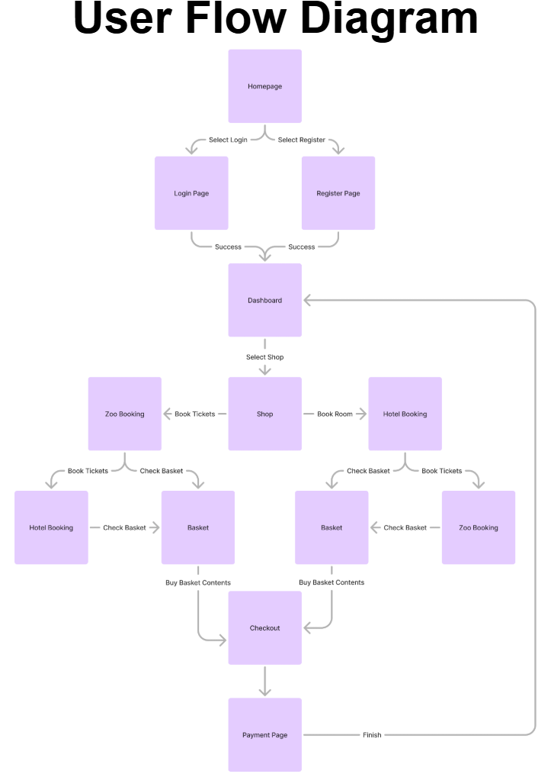

**Flowcharts**

Sign Up

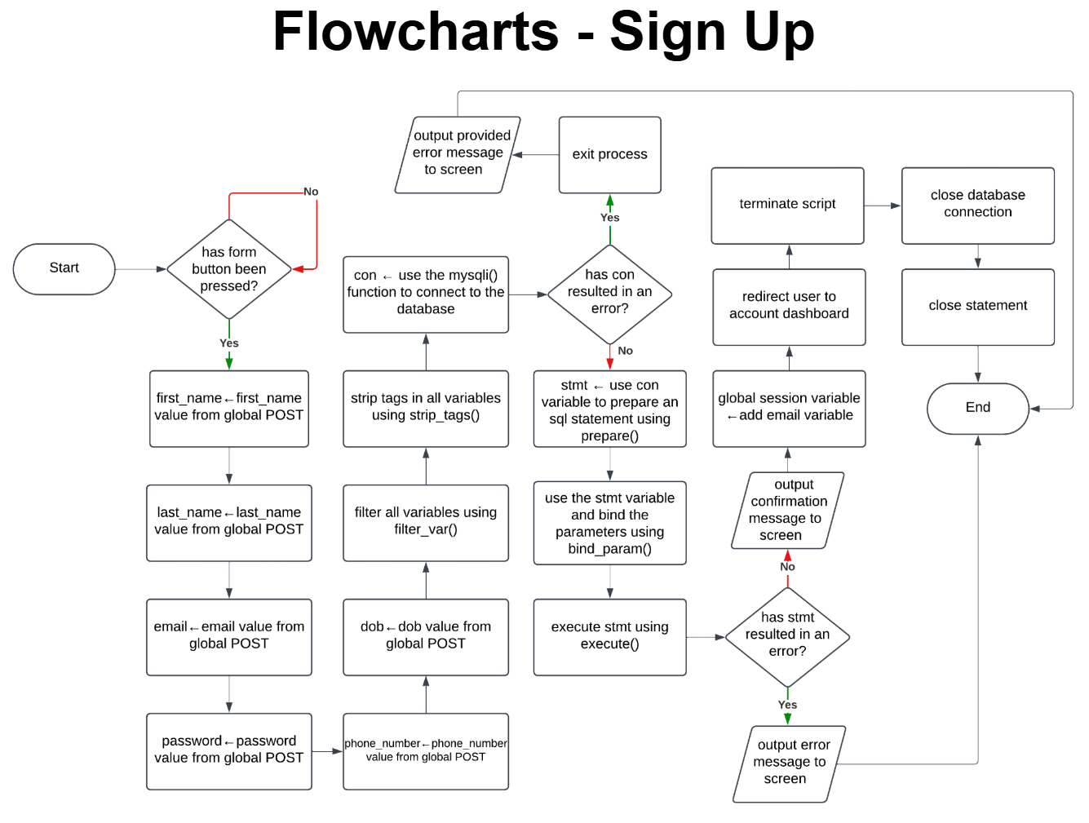

Login

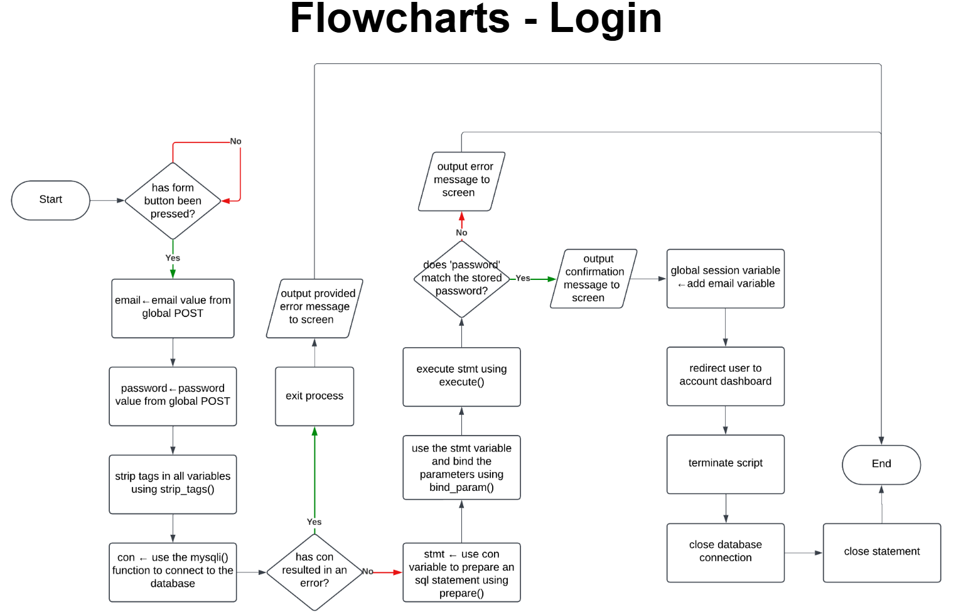

Logout

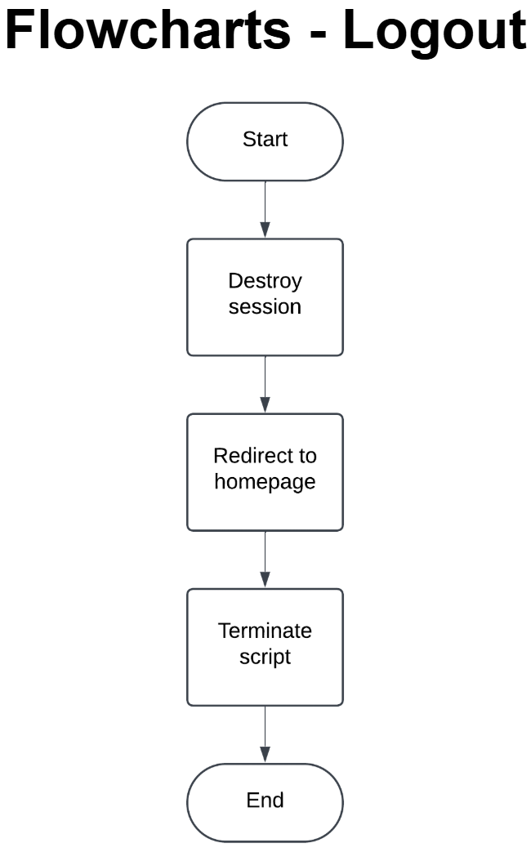

Saving Billing Information (from checkout)

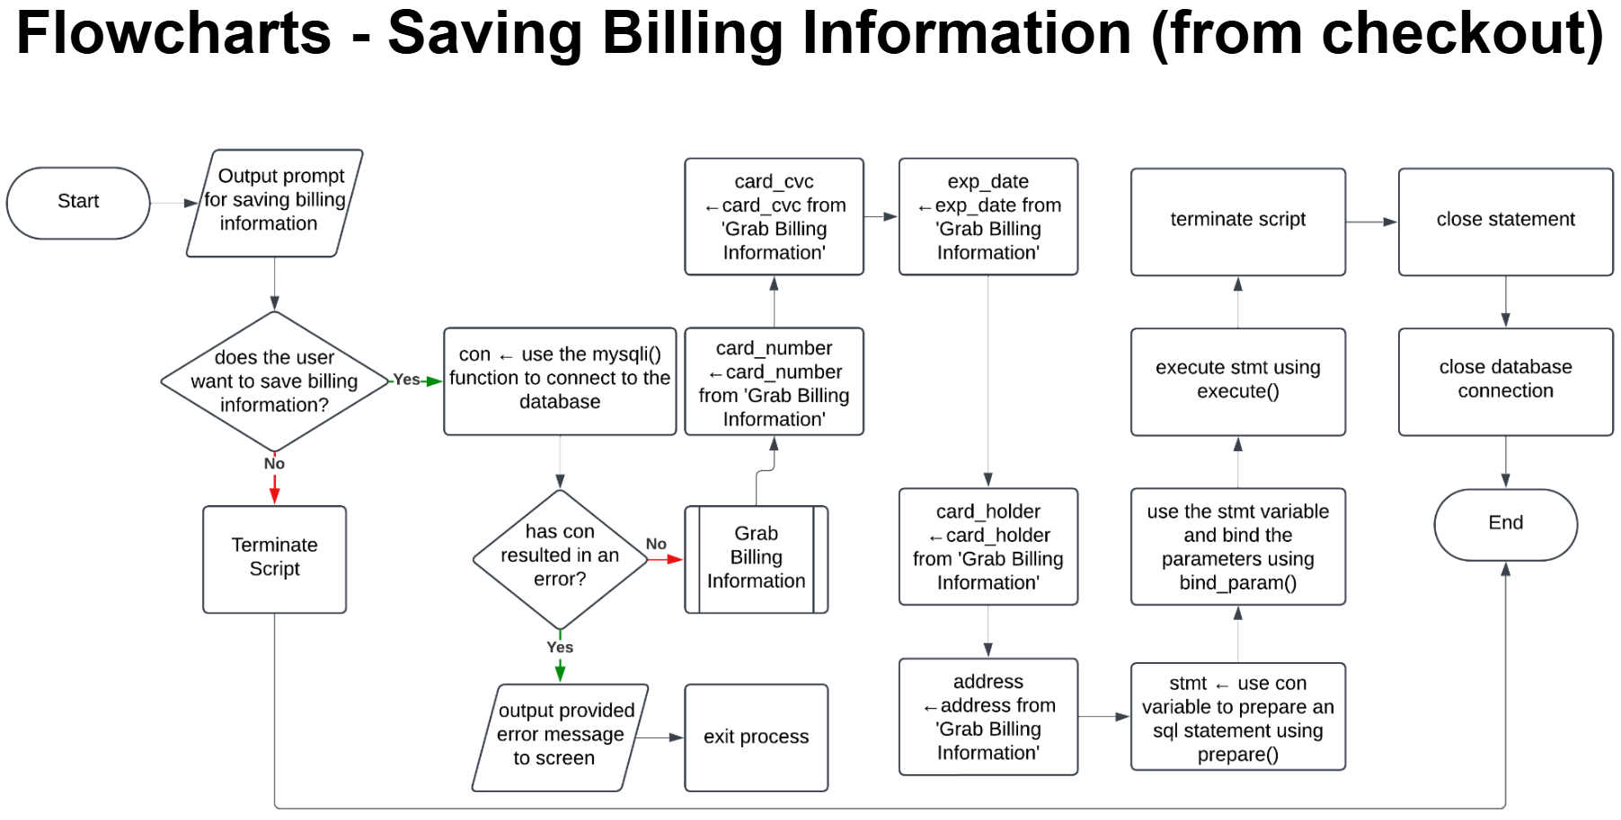

Grab Billing Information (from checkout)

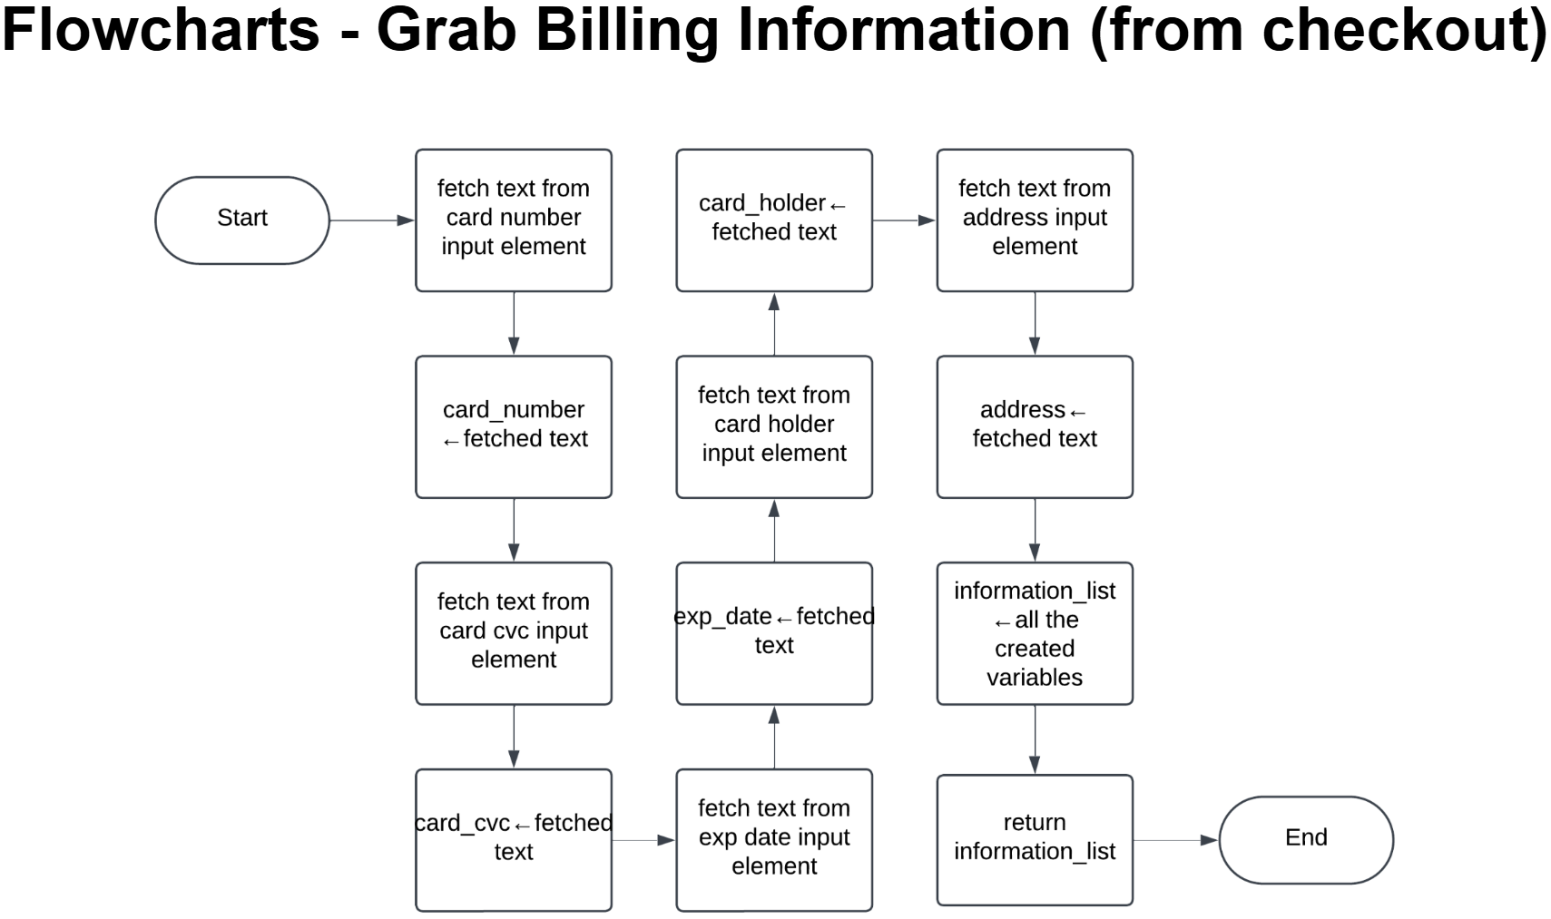

Booking Zoo Tickets

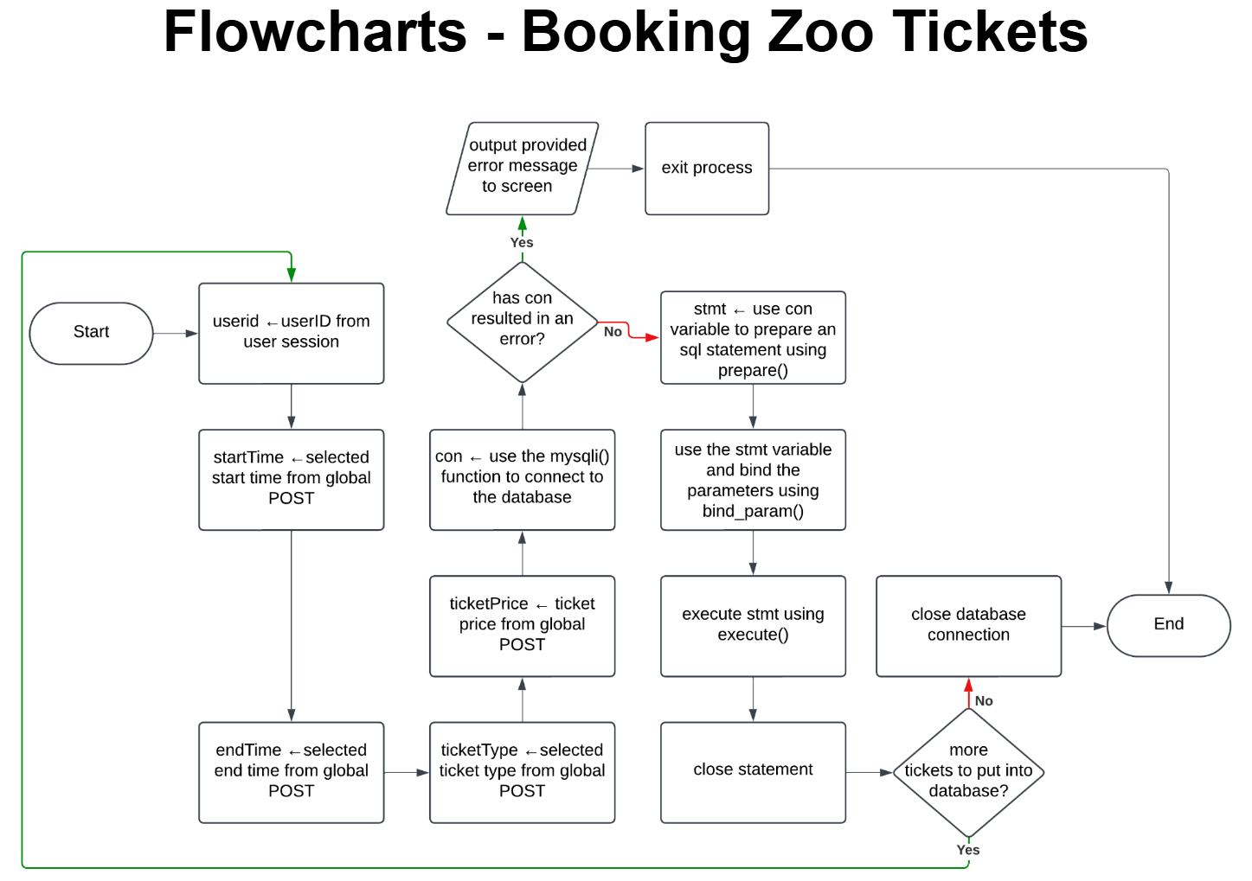

Display Zoo Availability

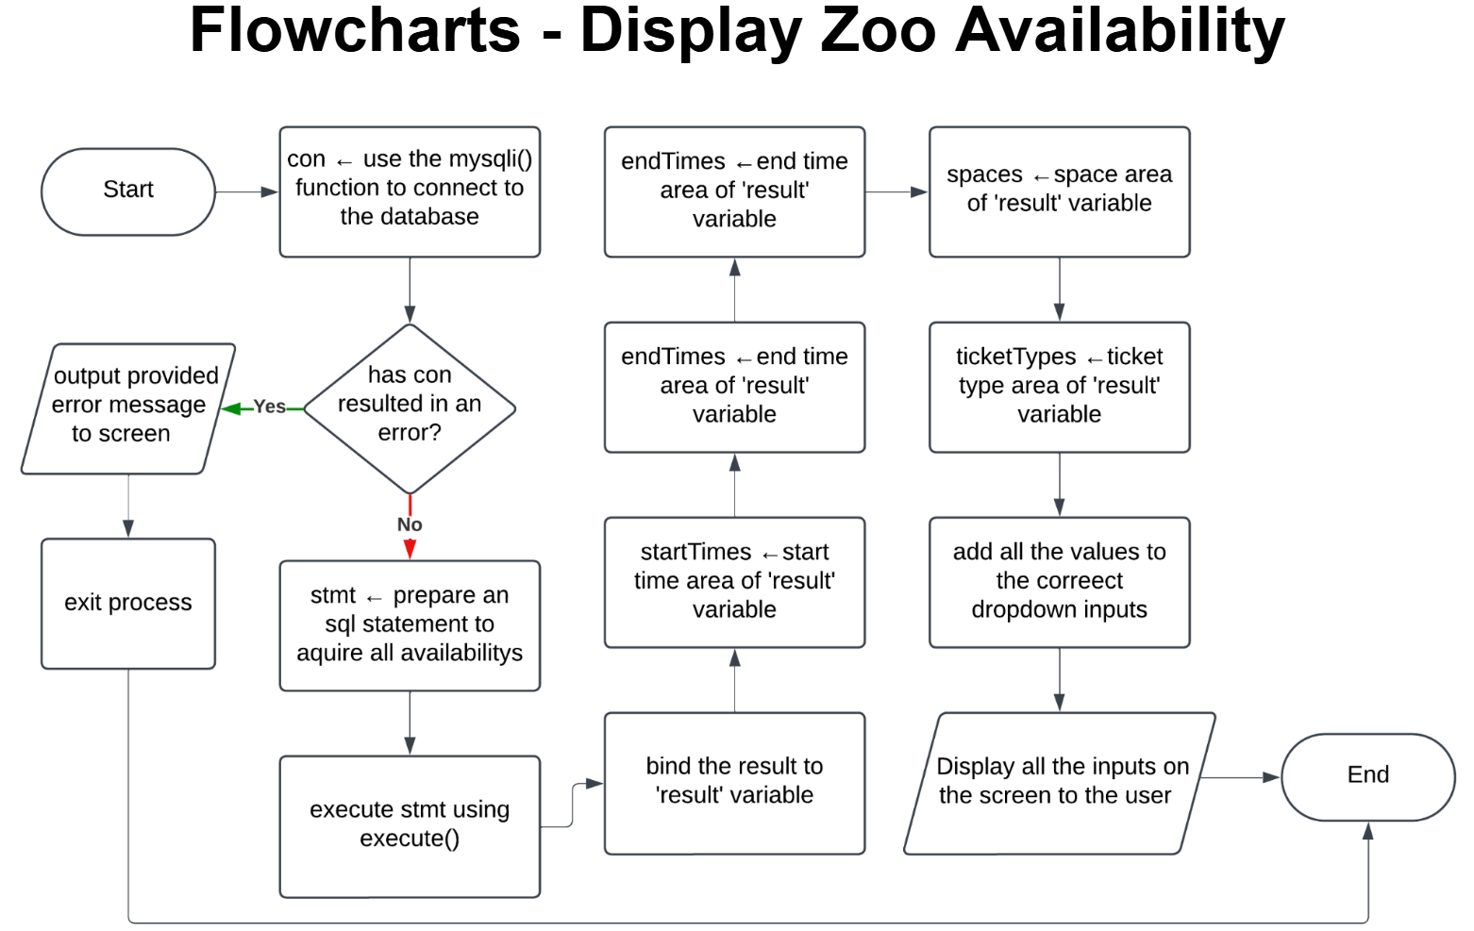

Booking Hotel Rooms

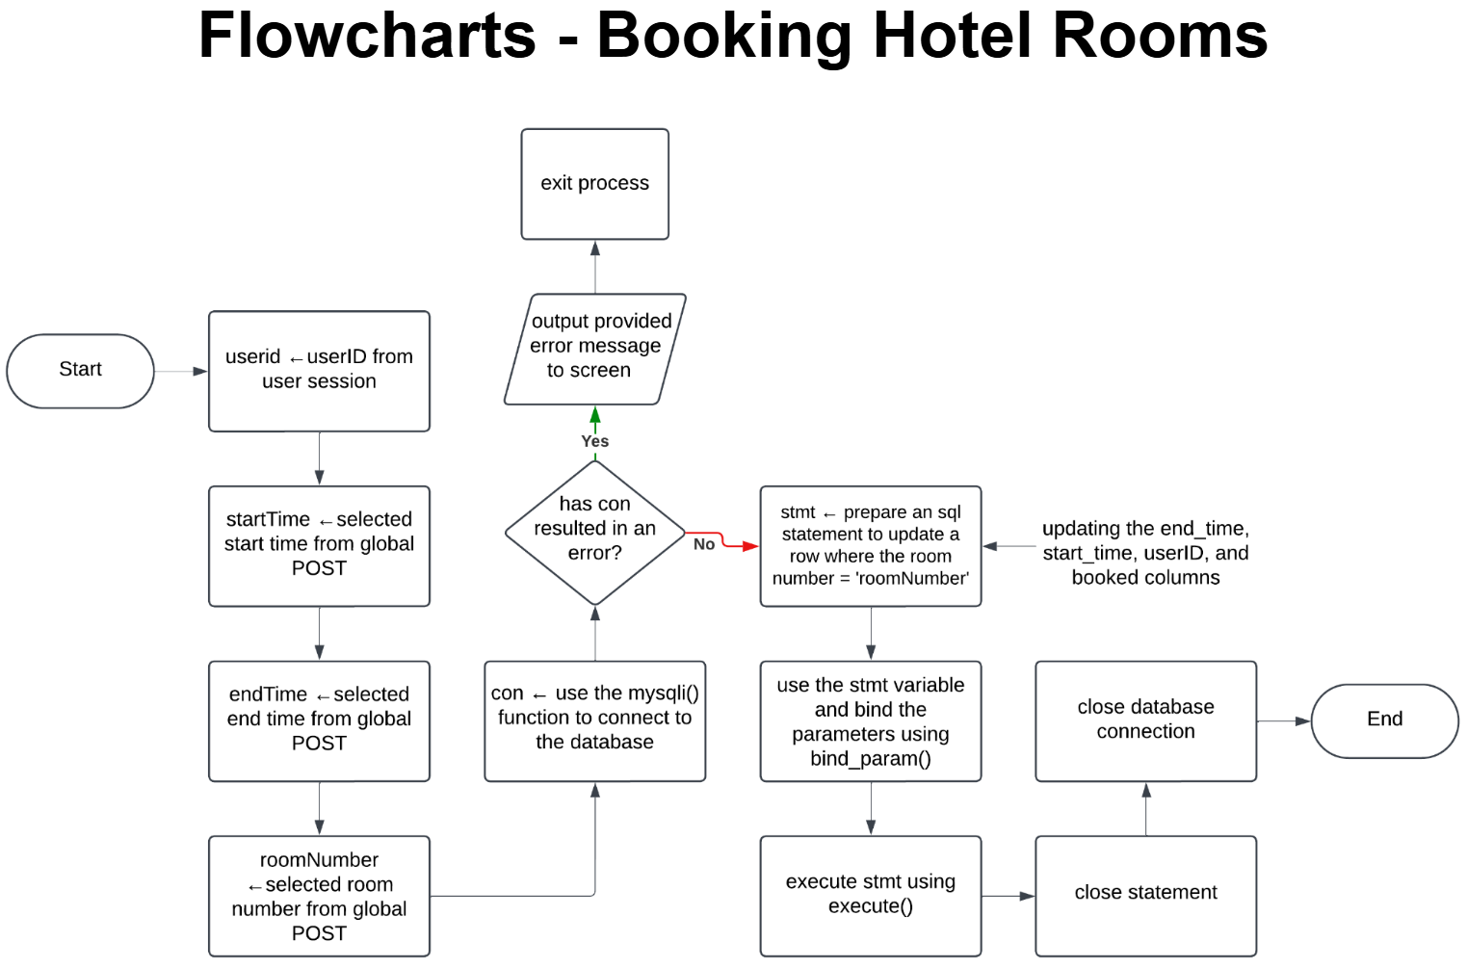

Display Hotel Availability

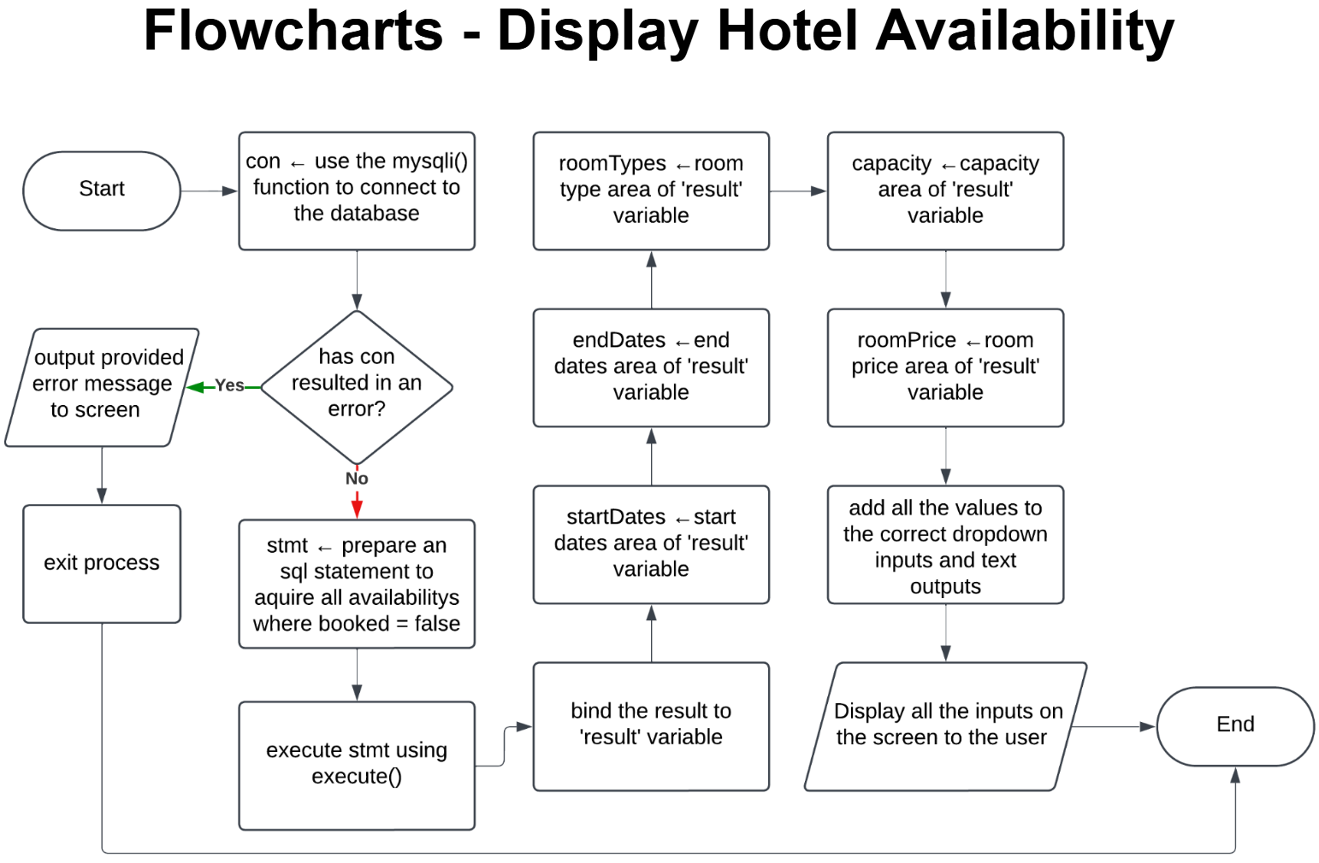

**Test Strategy**

|  |  |  |  |
| --- | --- | --- | --- |
| **Date of test** | **Component to be tested** | **Type of test to be carried out** | **Prerequisites and dependencies** |
| 12 February 2025 | Navigation bar | Black Box testing -> functional testing: Integration testing | No data inputs needed at this stage, tester will go through the navigation bar and test if all the correct pages are loaded. Hovering above the about, shop, map and more pages. |
| 12 February 2025 | Homepage | White box testing, Black box testing -> Functional testing: Integration testing, Unit testing | No data needed. Testing if all the buttons are functional, testing homepage unit, testing integration of homepage within the website. |
| 12 February 2025 | “About” Dropdown | White box testing, Black box testing -> Functional testing: Integration testing, Unit testing | No data needed. Testing if all the buttons are functional, testing about page unit, testing integration of about page within the website. |
| 12 February 2025 | “More” Dropdown | White box testing, Black box testing -> Functional testing: Integration testing, Unit testing | No data needed. Testing if all the buttons are functional, testing information units. |